Data Cleaning

Data Cleaning & Preparation in Excel
Before performing any analysis in Excel, it is important to ensure that the dataset is clean, consistent, and well-structured. Real-world data often contains inconsistencies such as duplicates, missing values, and improper formatting.
Data cleaning helps in:
- Improving data quality
- Ensuring accurate analysis
- Reducing errors in results
In this section, we will focus on essential data preparation techniques.

Remove Duplicates in Excel
Duplicate records refer to rows that contain repeated data within a dataset. These duplicates can affect analysis by leading to incorrect counts, totals, or insights. Excel provides a built-in feature to efficiently identify and remove duplicate entries.

How to Remove Duplicates
To remove duplicate records from a dataset, perform the following steps:
- Select the entire dataset (including headers).
- Navigate to the Data tab on the Ribbon.
- Click on Remove Duplicates in the Data Tools group.
- In the dialog box:
  - Select the columns you want to check for duplicates.
  - Ensure “My data has headers” is checked (if applicable).
- Click OK.
- Excel will display a message showing:
  - Number of duplicate values removed
  - Number of unique values remaining
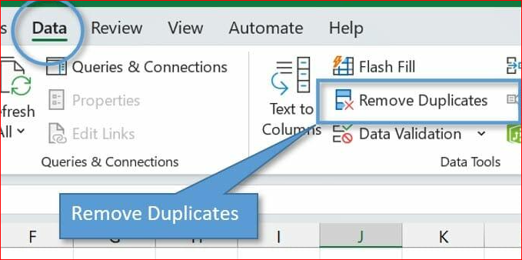

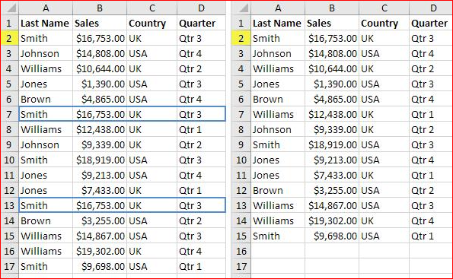

Key Considerations
- Excel always retains the first occurrence of a record
- Duplicate detection depends on selected columns
- It is recommended to keep a backup before removing duplicates

When to Use
- Cleaning raw datasets before analysis
- Removing repeated entries in reports
- Preparing data for dashboards or modeling

Expected Outcome
After applying this feature:
- Duplicate rows are removed
- Dataset becomes cleaner and more reliable
- Analysis results become more accurate

Text to Columns in Excel
Text to Columns is used to split data from a single column into multiple columns based on a defined delimiter or fixed width. This is particularly useful when dealing with combined or unstructured text data.

How to Use Text to Columns
To split data into multiple columns:
- Select the column containing the data.
- Go to the Data tab.
- Click on Text to Columns.
- Choose one of the following options:
  - Delimited (based on separator like space, comma)
  - Fixed Width (based on character position)
- Click Next.
- Select the appropriate delimiter (e.g., space).
- Click Finish.
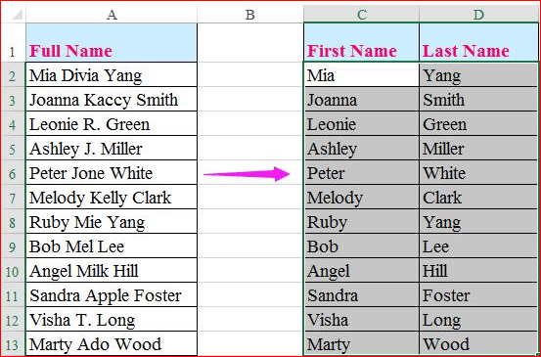

Key Considerations
- Always preview the split before applying
- Incorrect delimiter selection may lead to improper output
- Ensure adjacent columns are empty to avoid overwriting data

When to Use
- Splitting full names into first and last names
- Separating values like “City, State”
- Extracting structured data from text

Expected Outcome
- Data is separated into multiple columns
- Improves usability and analysis

Handling Missing Values in Excel
Missing values refer to empty or blank cells within a dataset. These missing entries can affect calculations, reporting, and overall data quality.
Before performing any analysis, it is important to first identify and handle missing values in a structured manner.

Identifying Missing Values
The first step is to locate where missing values exist in the dataset.

1. Using Go To Special
To quickly identify blank cells:
- Select the entire dataset
- Press Ctrl + G
- Click on Special
- Select Blanks and click OK
All blank cells in the dataset will be highlighted.

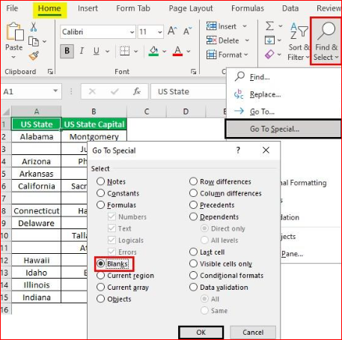

2. Using Filter
Filters help identify missing values column-wise, which is useful for analyzing specific fields.

Steps:
- Select the dataset
- Press Ctrl + Shift + L to apply filters
- Click the dropdown arrow in the column header
- Look for and select (Blanks)
- Click OK
Only rows with missing values in that column will be displayed.

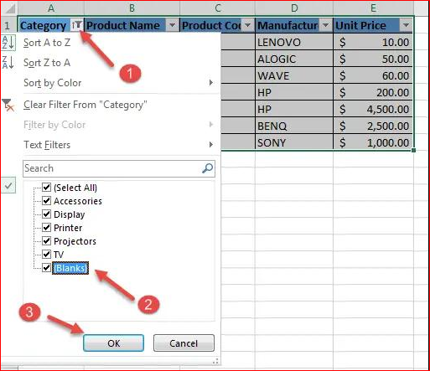

Understanding the Problem
Before filling or removing missing values, it is important to evaluate:
- What type of data is missing? (Numerical / Categorical)
- How many values are missing?
- Is the missing data random or meaningful?
- Will filling or removing affect the analysis?

Common Approaches to Handle Missing Values

1. Removal of Missing Data
- Delete rows or columns containing missing values
When to use:
- Very few missing values
- Missing data is not important
Limitation:
- May lead to loss of useful information

2. Replacement (Imputation) of Missing Values
Instead of removing data, missing values can be filled using appropriate techniques.

For Numerical Data
- Replace with Mean (Average) → when data has no extreme outliers
- Replace with Median → when data contains outliers
- Replace with 0 → only when logically valid

For Categorical Data
- Replace with Mode (most frequent value)
- Replace with "Not Available" / "Unknown"

Important Considerations
- Do not fill missing values randomly
- Always consider data distribution and outliers
- Incorrect handling can distort analysis results
- The method chosen should align with the objective of analysis

Filling Missing Values using Find & Replace
Excel allows quick replacement of blank cells using Find & Replace.

Steps:
- Select the dataset
- Press Ctrl + H
- In Find what, leave it blank
- In Replace with, enter the desired value (e.g., 0 or "Not Available")
- Click Replace All

Filling Missing Values using Formulas
For more controlled and logical handling, formulas can be used.

Example:
Replace blank cells with a value:
=IF(A1="", "Not Available", A1)
Replace blank cells with a number:
=IF(A1="", 0, A1)
Replace blanks manually or using formula logic
Calculate average:
• Select an empty cell
• Enter the formula:
=AVERAGE(A1:A10)
Press Enter
This gives the average of the column (ignoring blank cells automatically)

Fill Missing Values Using Formula
Now we replace blanks with the calculated average.

Using IF Formula:
In a new column, enter:
=IF(A1="", AVERAGE($A$1:$A$10), A1)
• Press Enter
• Drag the formula down

Key Advantage
- Provides conditional and flexible handling
- Useful for structured datasets

Important Considerations
- Choose the method based on the dataset and use case
- Do not fill values randomly
- Maintain consistency across the dataset

Note on Advanced Handling
Handling missing values using statistical methods (such as mean or median) and understanding the impact of outliers will be covered in upcoming topics.

Expected Outcome
After handling missing values:
- Dataset becomes complete and structured
- Errors in calculations are minimized
- Data is ready for further analysis

Standardization (Data Consistency) in Excel

Standardization refers to the process of converting data into a consistent and uniform format. Inconsistent data (e.g., ram, RAM, Ram) can lead to incorrect filtering, grouping, and analysis.
Ensuring consistency is a key step in data preparation before performing any analysis.

Step 1: Identifying Inconsistencies
Before standardizing, observe the dataset for:
- Variations in text case (upper/lower/proper)
- Extra spaces between words
- Unwanted or non-printable characters
Example:
- " Ram " (extra spaces)
- "RAM", "ram", "Ram" (case inconsistency)

Step 2: Standardizing Using Find & Replace
This method is useful for quickly correcting specific known values.

Steps:
- Select the dataset
- Press Ctrl + H
- In Find what, enter the incorrect value
- In Replace with, enter the correct value
- Click Replace All

When to Use
- When inconsistencies are limited and known
- When replacing specific values (e.g., "NY" → "New York")

Step 3: Standardizing Using Formulas (Recommended)
Formulas provide a more scalable and reliable way to standardize data.

1. Convert Text Case
- Convert to uppercase:
=UPPER(A1)
- Convert to lowercase:
=LOWER(A1)
- Convert to proper case:
=PROPER(A1)

2. Remove Extra Spaces
=TRIM(A1)
Removes leading, trailing, and extra spaces between words.

3. Remove Unwanted Characters
=CLEAN(A1)
Removes non-printable characters (often from imported data).

4. Combine Cleaning Functions (Advanced)
=PROPER(TRIM(A1))
This ensures:
- No extra spaces
- Proper capitalization
Key Difference Between Methods
Method | Use Case
Find & Replace | Quick fix for specific known values
Formulas | Scalable and consistent for large datasets
Important Considerations
- Always standardize data before analysis
- Ensure consistency across the entire column
- Prefer formulas for large datasets
- Avoid manual corrections for repeated patterns

Expected Outcome
After standardization:
- Data becomes uniform and consistent
- Duplicate mismatches are reduced
- Sorting, filtering, and analysis become accurate

